* Difference between Document Object and Windows Objects

**Windows Object**

* Windows object is global object of client-side JavaScript. It acts as roof and represent windows browser containing the DOM (Document object model).
* Combinations of Global JavaScript objects, functions, variables, Commands works in windows browser and helps in browsing on Web Page.
* For Instant Searching, opening new tab, closing a tab and by clicking an option in the web page and it directs you to another web page these actions with the help of DOM are known as “Windows Object”.
* Examples:
* window.open() - Opens a new window
* window.close() - Closes a window
* window.moveTo() – Move to the current window

The above methods are shown to perform in Console.log to get result, whereas the same methods are done on webpage by performing an action, clicking and browsing. This is known as Windows Object.

**Document Object**

* The Internal Manipulations and functionalities to run a web page is known as Document object.
* The Document object is the HTLM which appears in windows browser and acts as an interface between the server and the user, it allows dynamic updates and interactions with web page content.
* The DOM manipulation tool offers methods to access and manipulate the structure and content of a document, such as getElementByI (), querySelector(), createElement(), and inner HTML.

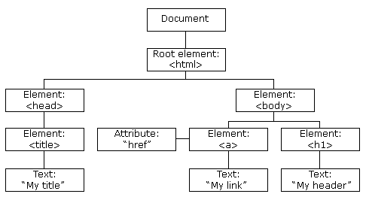

The above image is the Tree structure Of DOM which allows to manipulate and helps to create a Webpages in systematic way.